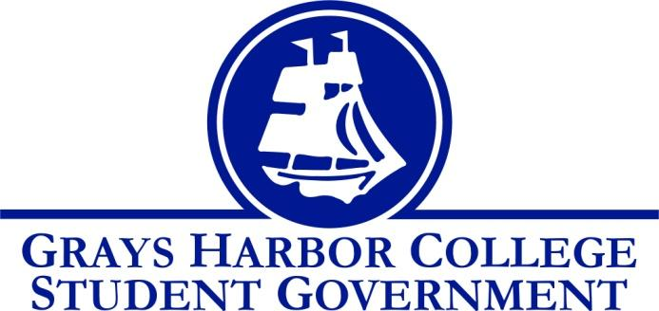

**Council Meeting Minutes**

September 19th, 2016 @ 1:00 P.M.

**Call To Order**

1:06 P.M.

**Roll Call**

Yulisa Morelia

Savannah Burbank

Taylor Moreno

Chloe Converse

Sierra Cummings (excused)

Aaron Tuttle

**Approval of Agenda**

Chloe Converse motions

Taylor Moreno seconds

Vote passes 4-0-0

**Approval of Minutes**

**New Business**

**Statements from the Gallery**

**Executive Reports**

**President (Yulisa Morelia)**

* No report

**Vice-President (Savannah Burbank)**

* No report

**Executive Officer of Government Relations (Chloe Converse)**

* Chloe talks about what she is doing to promote voter registration. She says that she is going to have the voter registration website set up on a laptop for students to come in the student life office and register to vote. Her goal is to get at least 25 people registered.

**Executive Officer of Budget & Finance (Sierra Cummings)**

* No report

**Executive Officer of Community Relations (Taylor Moreno)**

Taylor talks about the packet that he created for the blood drive. The packet includes parental consent forms, general information about the blood drive, and a sign-up sheet. His goal is to have at least 40 individuals sign up to donate. The blood drive will be held the 4th and 5th of October in the 4000 building.

**Advisor Report (Aaron Tuttle)**

Aaron discusses the involvement fair and talks about taking turns tabling. He also states that our weekly meetings will now be every Tuesday at 1 P.M in the Student Life conference room.

**Unfinished Business**

**Announcements**

**Executive Session**

**Adjournment**

Taylor Moreno motions

Chloe seconds

1:30 P.M.