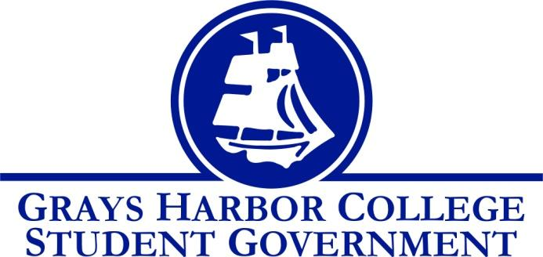
Council Meeting Minutes
September 27th, 2016 @ 1:00 P.M.

Call To Order
1:02 P.M.
Roll Call
Yulisa Morelia
Savannah Burbank
Taylor Moreno
Chloe Converse
Sierra Cummings
Aaron Tuttle
Approval of Agenda
Chloe Converse motions
Taylor Moreno seconds
Vote passes 4-0-0
Approval of Minutes

New Business

Statements from the Gallery

Executive Reports
President (Yulisa Morelia)
- Yulisa reminds us to fill out our travel expense voucher for the food that we paid for ourselves on our way to the Student Leadership Conference.
- Yulisa also asks our input on when a good time for a BBQ for all students would be. The purpose of the BBQ is to make good use of the leftover food from New Student Orientation. As a group, we decide on Wednesday October 12th. It is decided that Yulisa will put in the facilities request.
- She also explains “Darby’s bowties.” She says every Monday staff and students can wear bowties/scarfs in order to support a different cause every week.
- She reads us an email talking about how our work ties back to ASGHC decision making.
- She goes over section 3 of the bylaws that cover institutional committee introduction.
- She states that she wants us to try and email her every Friday with a list of things we need to go over at the meetings on Tuesdays so that she can put it on the agenda.
Vice-President (Savannah Burbank)
- Savannah described that her and Sierra are going to be working on promoting sporting events. They are very interested in increasing attendance at games. She says that a couple of the ways they plan on promoting them are by writing on the white boards in class rooms and creating signs.
Executive Officer of Government Relations (Chloe Converse)
- Chloe updates us on voter registration. She says that she’s not sure of the results yet because the website only allows her to check them at certain times.
- She updates us on how debate night went. About 12 people attended and they had a great conversation afterwards regarding the election.
- She says that she still plans on putting the laptop out for students to register to vote.
Executive Officer of Budget & Finance (Sierra Cummings)
- Sierra says that she plans on increasing attendance at sporting events by promoting them in many different ways: talking with coaches about donating free swag to handout at games, painting signs, writing on white boards in classrooms, table tents, and setting up a “meet the athletes” day so that students know who they’re cheering for.
- Aaron brought up an idea to have a tailgate before the games.
- No financial update
Executive Officer of Community Relations (Taylor Moreno)
Taylor updates us on the blood drive and says that he’s made good progress with 27 people signed up to donate so far. He said he’s been tabling and walking around in the HUB and Harbor Landing handing out flyers, and plans on doing the same in the 2000 and 4000 building.

Advisor Report (Aaron Tuttle)
Aaron reminds us all that we need to get our food handlers permit and turn them in to him or Lindsey.
He tells us that we need to work on promoting clubs and asks for our input on ways to do that.
He brings up that our Grays Harbor College app is doing good and the number of users has significantly increased. Even though more people have it, he still would like us to promote it as best as we can to get as many people as possible.
He also tells us to not stress too much about our hours, just make sure we are getting our work done.

Unfinished Business

Announcements
Executive Session
Adjournment
Taylor motions
Chloe seconds
4-0-0

