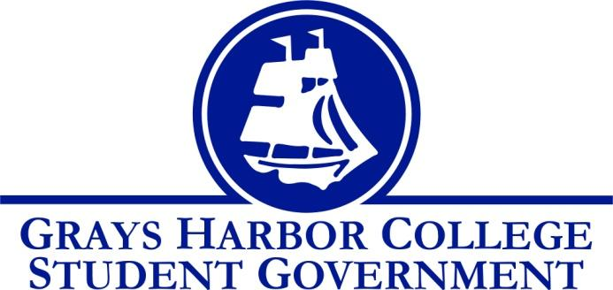
Council Meeting Minutes
October 5th, 2016 @ 10:00 A.M.

Call To Order
1:01 P.M.
Roll Call
Yulisa Morelia
Savannah Burbank
Sierra Cummings
Taylor Moreno (excused)
Chloe Converse
Approval of Agenda
Savannah Burbank motions
Sierra Cummings seconds
Vote passes 4-0-0
Approval of Minutes
Savannah Burbank motions
Sierra Cummings seconds
Vote passes 4-0-0
New Business
James Umphre, the e-learning coordinator at Grays Harbor College, joined our meeting to discuss making Student Life a “class” on canvas that all students would be enrolled in. The point of it would be to make Student Life more transparent by informing the students of upcoming events, having surveys, having important/informational documents uploaded, and any other information that would be useful to the students. We brain stormed how we would like to customize our page. Yulisa explained that this would have a more positive outcome then the Student Life tab on the Grays Harbor College website because this is easier to access and students wouldn’t have to go out of their way to get to the page.
Statements from the Gallery

Executive Reports

President (Yulisa Morelia)
- Yulisa stated that she booked a meeting with Dr. Minkler to discuss Student Government initiatives.
- She briefly discussed the e-team and explained that within the next week we will be setting up our own “Student Government” page.
- She asked for us to send her any pictures that we have from events that we’ve been to/put on because she is working on her presentation for the board of trustees.
- She brought up the idea of having a student forum where we sit in the HUB and are open for any students or staff to come ask us questions or present any concerns. An idea that we have a certain topic set for each forum was also brought up.
- She said that her and Taylor Moreno (Officer of Community Relations) are going to start fundraising and making an outline for Relay for Life.
- The BBQ that we are putting on will be on October 12th. Yulisa said that she will make a sign up sheet for us to mark down when we are able to serve; she also put in a facilities request for this event.
Vice-President (Savannah Burbank)
- Savannah discussed that Tom Sutera (GHC athletic director) is going to making pocket sized flyers that include the dates of all sporting events. The goal is that these will help increase attendance at the athletes games.
Executive Officer of Government Relations (Chloe Converse)
- Reminds us that she is putting on the second debate night tonight (October 5th) at 5:45
- She received the voter registration spreadsheet that shows the activity of the students, and she reports that at least 13 people have registered to vote.
Executive Officer of Budget & Finance (Sierra Cummings)
- Sierra updates that she has been making signs for the past two games and hanging them in the HUB and plans on continuing that throughout the year. We started discussing having a tailgate before one of the volleyball games where all students are welcome. As of now, the tailgate is planned for November 2nd at Aberdeen High School for sophomore night. We plan on having prizes, food, games, and possibly a meet and greet.
Executive Officer of Community Relations (Taylor Moreno)
- No report (absent)

Advisor Report (Aaron Tuttle)
Aaron announced that we officially have two new work study workers, Andrea and Lisa.
Reminds us of the all staff meeting this Thursday (October 6th) at 7am.
Also reminds us of the legislative academy that the members of Student Life are attending November 18th and 19th.

Unfinished Business

Announcements
Executive Session
Adjournment
1:51 P.M.

