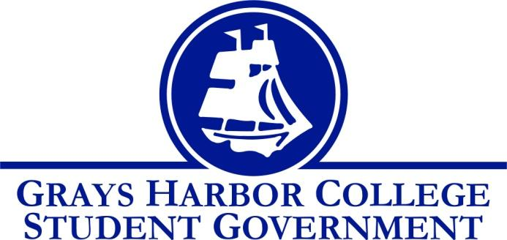
Council Meeting Minutes
October 11th, 2016 @ 1:00 P.M.

Call To Order
1:05 P.M.
Roll Call
Yulisa Morelia
Savannah Burbank (excused)
Sierra Cummings
Taylor Moreno
Chloe Converse
Approval of Agenda
Chloe Converse motions to approve
Taylor Moreno seconds
3-0-0
Approval of Minutes
Sierra Cummings motions to approve
Chloe Converse seconds
3-0-0
New Business
Andrew Glass (Chief of Information Technology) External use of student computer labs. GHC wants to rent out its facilities. There were thoughts about renting labs to students. The cost of this would be a $100 IT fee that covers damaged replacements. There will always be an employee there and the fee covers that employee’s salary. The minimum rent fee would be $130. That money will be dispersed by a percentage to cover salary. There are 11 labs, and 8 or 9 open labs. These are private companies wanting to rent out the labs, not students.
Taylor Moreno motions to approve the IT fee in computer labs and usage.
Chloe converse seconds.
Vote passes 3-0-0
Old Business
James Umphres (eLearning Coordinator) Continuation of Student Life Page. James gave a visual presentation/tutorial and the choker template for canvas announcements for all students to see. He needs a list of events and schedules so that he can post them and update the announcements on canvas every week. Some ideas were made that we could set up a “discussion” and “Game Schedule” as different pages.
Statements from the Gallery

Executive Reports
President (Yulisa Morelia)
- Yulisa said that she is finalizing ideas with Taylor about Relay for Life.
- Student Government: Dr. Opstad with the Aberdeen school district and Curt Dawson the Aberdeen school district Super Intendant are discussing/asking if we want to help them with their building projects. They want students to renovate the gym. 87% of students agreed to needing a new wellness center. There was talk of a separate project for a new wellness center (secondary gym). The big question asked is if the facility they’re proposing meets the needs of the students.
- Gave student Life report
- Said she has a meeting with Dr. Minkler on Friday
Vice-President (Savannah Burbank)
- Absent (excused)
Executive Officer of Government Relations (Chloe Converse)
- Updated that there were a total of 13 people who registered
- Brought up that the next debate night is the last one, and that pizza will be provided.
Executive Officer of Budget & Finance (Sierra Cummings)
- Sierra says that she has been working on promoting athletics.
- A Pink Out Game will be help October 26th at 7 P.M. There will be a pink basket, ribbons, pink ball, and Charlie.
- She talked about making a “Meet the Athletes” for every sports season.
- Her and Pam put together a Halloween Workout.
- Her and Savannah are putting together a Tailgate before the November 2nd Volleyball game that will include live music, free food, and games.
Executive Officer of Community Relations (Taylor Moreno)
Updated that there was a total of 38 units of blood donated.

Advisor Report (Aaron Tuttle)
Diversity and Equity Center Grand Opening will be on Thursday at 12 P.M..
Reminder about the Legislative Academy November 18th and 19th.
Next week’s meeting – Savannah will not be there.
Calendars
Canvas Site
Student rec and wellness center
Entertainment coordinator interviews

Unfinished Business

Announcements
Diversity Center Grand Opening October 13th
Dodgeball October 24th
Fall Festival October 25th

Executive Session
Adjournment
Sierra Cummings motions to adjourn
Taylor Moreno seconds
3-0-0

