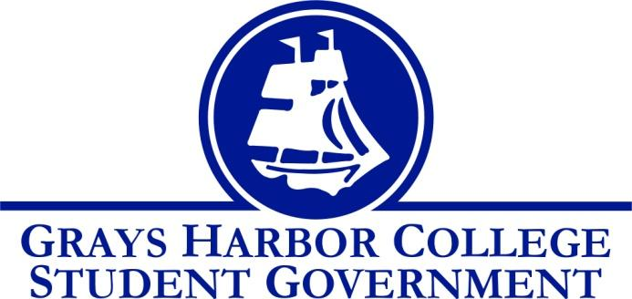
Council Meeting Minutes
October 19th, 2016 @ 1:00 P.M.

Call To Order
1:01 P.M.
Roll Call
Yulisa Morelia - President (excused absence)
Savannah Burbank - Vice President
Sierra Cummings – Executive Officer of Budget & Finance
Chloe Converse – Executive Officer of Government Relations
Taylor Moreno – Executive Officer of Community Relations

Approval of Agenda
Taylor Moreno motions
Chloe Converse seconds
3-0-0
Approval of Minutes
Taylor Moreno motions
Chloe Converse seconds
3-0-0
New Business

Statements from the Gallery
Funding request from Veterans club to attend a conference in January. They were unable to have a member from the Veterans club to come to the meeting so it was tabled until next week.
Executive Reports
President (Yulisa Morelia)
Absent

Vice-President (Savannah Burbank)
Discussed who is going to turn into the facilities request for the tailgate at the Aberdeen High School on November 2nd. It was decided that Tom Sutera (athletic director) will take care of it.
Reminded the staff to set aside time to be part of the Fall Festival this Tuesday to volunteer their time for our cookie decorating booth from 5 P.M. to 8 P.M.
Reminded students to make drafts of what they want their canvas page to look like so that they can get approved by James and Aaron.
Reminded staff to set aside time to help at the tailgate before the volleyball game on November 2nd.
Discussed that Aaron and I will be assigning people to committees this week.

Executive Officer of Government Relations (Chloe Converse)
Reminded us that the last debate night is October 19th and she’s expecting a good turnout.
Announced that she met her goal of 25 people who registered to vote.

Executive Officer of Budget & Finance (Sierra Cummings)
Discussed the Pink Game that will be October 26th. Everyone should be their wearing pink to support the volleyball team and breast cancer awareness.
Discussed the Halloween workout that her and Pam Aho are working on. Asked staff to put aside time to support this event by being there, wearing bright colors, and helping out. She requested $300 for food for the students who attend.
Chloe Converse motions to approve the supplies.
Taylor Moreno seconds
3-0-0

Executive Officer of Community Relations (Taylor Moreno)
Discussed Relay for Life fundraisers. Some ideas were a car wash, penny wars, and tournaments where you have to pay to enter.

Advisor Report (Aaron Tuttle)
Reminded staff about working on their canvas setup, setting aside time for fall festival and the tailgate, and letting him know who can make it to Legislative Academy.

Unfinished Business

Announcements
Executive Session
Adjournment
Sierra Cummings motions to adjourn
Chloe Converse seconds
3-0-0
1:45 P.M.

