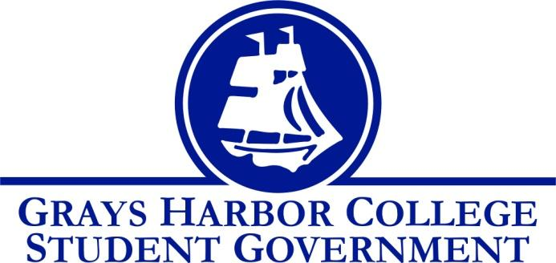
Council Meeting Minutes
October 25, 2016 @ 1:00 P.M.

Call To Order
1:09 P.M.
Roll Call
Yulisa Morelia – President
Savannah Burbank – Vice President
Sierra Cummings – Executive Officer of Budget and Finance
Taylor Moreno – Executive Officer of Community Relations
Chloe Converse – Executive Officer of Government Relations
Approval of Agenda
Taylor Moreno motions
Chloe Converse seconds
3-0-0
Approval of Minutes
Chloe Converse motions
Taylor Moreno seconds
3-0-0
New Business
Dr. Minkler, Curtis Dawson (director of the YMCA), and Dr. Opstad (Supt. Of the Aberdeen School Dist.) came to talk about the collaboration with building a YMCA at the bottom of the hill on college property. They also mentioned that the Aberdeen Elementary needs to be torn down rebuilt, and that a good place for it to be rebuilt is as close to the college as possible due to the college being the emergency evacuation grounds for the elementary. The only thing holding back that plan is whether or not the ground on which it would be built is owned by the college or not. They are waiting on an attorney to get back to them with that information. The ground they are talking about it what is currently the practice soccer field.
The other big topic mentioned was partnering with the YMCA and the Aberdeen Elementary to build a YMCA at the bottom of the hill on campus. They believe this is a crucial part of keeping the community up and involved. If the college is unable to approve the funding, the whole idea would be shut down. By having three partners, Student Government wouldn’t necessarily have to put any money towards this project because we’d have a variety of pockets for money. The only cost for the students would be about $100 per quarter which would be about $300 per year. The YMCA would have openings to hire students. One perk to the students is they would be paying less than other people from the community. If approved, the YMCA will be built and ready to go in 2020 if the bond passes the first time. In order to keep the costs as low as possible, the YMCA and the elementary would be connected so that it was considered one project. Having the elementary so close to the college and the YMCA would be beneficial because it would plant a seed in young children’s heads about fitness/health and college education which would help future generations. The YMCA would potentially offer a dentist and a nurse that would be open to students. They could also hire an athletic trainer/physical therapist that would be available at the athletic games (free of charge to the college.) The overall contribution from the college would be the property and the student fees. Also, rather than athletic fees going to build a new gym, they would go towards the YMCA. We discussed other colleges who have YMCA’s and will be touring those campuses to get ideas.

Statements from the Gallery

Executive Reports
President (Yulisa Morelia)
- Reminded staff about the Fall Festival
- Mentioned that it’d be helpful if people from Student Life could help in the Student Government booth
Vice-President (Savannah Burbank)
- Reminded staff of the tailgate on November 2nd and asked everyone to be there if possible
- Told staff that everyone has been assigned to a committee and they will get an email with more information about their specific committee
Executive Officer of Government Relations (Chloe Converse)
- Reported that her last debate night was the most successful one yet
- Voter registration is now over but she met her goal
Executive Officer of Budget & Finance (Sierra Cummings)
- Left early from meeting (excused)
Executive Officer of Community Relations (Taylor Moreno)
Discussed Relay for Life fundraisers

Advisor Report (Aaron Tuttle)
Reminders:
Black Light Dodgeball October 31st
All-staff meeting November 3rd
Legislative Academy November 18th-19th
Tailgate needs
Unfinished Business
The vets asked for funding of $1500 for a member to attend a nationwide student council meeting for vets. This meeting would help them become leaders and train staff to have more abilities. They would gain networking abilities and be able to provide better speakers. They are currently working on a fundraiser to help the other two members be able to go. They heard about the training two years ago but waited until they thought they could afford it. This training fits their mission by training people for leadership and helping reach more students, as well as being part of the community and providing better mentorship.
Announcements
Executive Session
Adjournment
2:41 P.M.

