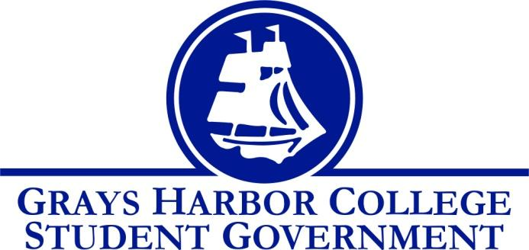
Council Meeting Minutes
November 1st, 2016 @ 1:00 P.M.

Call To Order
1:00 P.M.
Roll Call
Yulisa Morelia – President
Savannah Burbank – Vice President
Sierra Cummings – Executive Officer of Budget and Finance (absent – unexcused)
Taylor Moreno – Executive Officer of Community Relations
Chloe Converse – Executive Officer of Government Relations
Approval of Agenda
Taylor Moreno motions
Savannah Burbank seconds
3-0-0
Approval of Minutes
Savannah Burbank motions
Taylor Moreno seconds
3-0-0
New Business

Statements from the Gallery

Executive Reports
President (Yulisa Morelia)
- Reminds us that she has a meeting with the Board of Trustees coming up so she needs pictures from events that we have been putting on.
- Discusses Student Government page and that everyone should be working on their page so that they have a draft ready for Aaron to approve.
- Announces that everyone on Student Government has been assigned to a tenure committee and they should be receiving an email about when their committees meet.
Vice-President (Savannah Burbank)
- Reminds every one of the tailgate on November 3rd and asks everyone who is available to be at the Aberdeen High School around 4 P.M.
- Seconds what Yulisa said about the committees and explained that some people have been assigned to more than one committee.
Executive Officer of Government Relations (Chloe Converse)
- Reminds us of the Open House Debate night on Tuesday November 8th where everyone is welcome and refreshments will be provided.
Executive Officer of Budget & Finance (Sierra Cummings)
- Absent (unexcused)
Executive Officer of Community Relations (Taylor Moreno)
Discussed Relay for Life fundraisers and reminded us that the Relay for Life team is open to all students.

Advisor Report (Aaron Tuttle)
Reminds us of the Legislative Academy November 18th-19th
Discusses that we need to start thinking about winter events and a new schedule of events will be made soon
Reminds us to be involved with Relay for Life if possible
Discusses that we could potentially be having an M.L.K Day of Service
Explains that Student Government has a goal to decrease transparency but recruiting people for unpaid positions where they would attend Student Government meetings and help with decision making. There is a potential for some sort of incentive.
Unfinished Business
We voted on the contingency funding request that was tabled on October 25th at the Student Government meeting. The request was denied because the use of this money would deplete all of their funds and they wouldn’t have anything left to put on any events the rest of the year. Also the members attending could potentially only have one quarter left at Grays Harbor College which means that the skills that they gained wouldn’t necessarily benefit the college.
Taylor Moreno motions to deny the request
Chloe Converse seconds
3-0-0
Announcements
Executive Session
Adjournment
1:46

