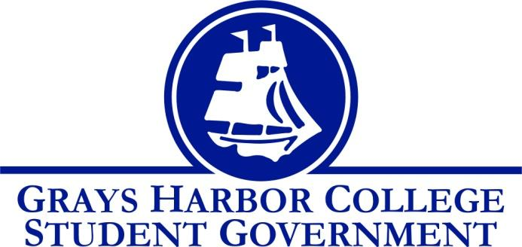
Council Meeting Minutes
November 29th, 2016 @ 1:00 P.M.

Call To Order
1:05 P.M.
Roll Call
Yulisa Morelia
Savannah Burbank
Sierra Cummings
Taylor Moreno
Chloe Converse
Approval of Agenda
Taylor Moreno motions
Chloe Converse seconds
Vote passes 4-0-0
Approval of Minutes
Chloe Converse motions
Taylor Moreno seconds
Vote passes 4-0-0
New Business

Statements from the Gallery

Executive Reports

President (Yulisa Morelia)
- No report
Vice-President (Savannah Burbank)
- Savannah reminded everyone to keep up to date with their committees.
Executive Officer of Government Relations (Chloe Converse)
- Chloe spoke about the WACTCSA meeting that she attended at Legislative Academy. She read the list of ideas to work on and mentioned that they usually take 3 to 7 years to actually happen.
Executive Officer of Budget & Finance (Sierra Cummings)
- Sierra asks if anybody has any suggestions for the Budget Committee. It was decided that Sierra, Savannah, and Yulisa are on that committee. She also asks for suggestions for meet the athletes. It was decided that between one of the men’s and women’s basketball games she will host a meet the athletes event.
Executive Officer of Community Relations (Taylor Moreno)
- Taylor mentions that he is currently working on some fundraising ideas. A few that he mentioned are a car wash, photo contest, vending machine, krispy Kreme sale, jellybean count, basket silent auction, trivia night, cuss jar, and trunk sale. He also reminded us to sign up to join the team if we have not already done so.

Advisor Report (Aaron Tuttle)
Aaron reminds the people who are going to Legislative Academy that it is the 18th-19th and they would be leaving the school on Friday around noon.
He reminds the students who are going to be available that there is going to be a New Student Orientation December 13th.
He asks Student Government members to print off their winter schedules and give him a copy.

Unfinished Business

Announcements
Executive Session
Adjournment
1:51 P.M.

