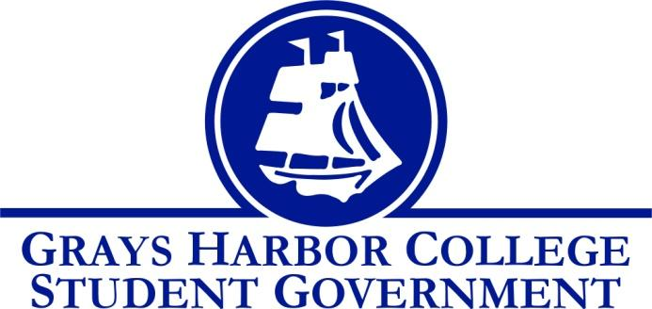
Council Meeting Minutes
January 11th, 2017 @ 1:00 P.M.

Call To Order
1:04 P.M.
Roll Call
Yulisa Morelia
Savannah Burbank
Sierra Cummings
Taylor Moreno
Chloe Converse
Approval of Agenda
Taylor Moreno motions
Chloe Converse seconds
Vote passes 4-0-0
Approval of Minutes
Chloe Converse motions
Taylor Moreno seconds
Vote passes 4-0-0
New Business
Aaron Tuttle requests the funding of about $150 to buy 1,000 condoms. These condoms are placed in the student life office and are free of charge to students.
Savannah Burbank motions
Sierra Cummings seconds
Vote passes 4-0-0

Statements from the Gallery
Contingency request from the Diversity Center: The Diversity Center asked for funding of $3,400 to cover the costs of events/supplies for the rest of the year. They plan on bringing in a speaker in March to educate students about Islam. They also plan on purchasing a documentary about police brutality. The money that goes towards the documentary will give us all the rights to show it on campus permanently. The Diversity Center also holds many potlucks/celebrations that teach students about culture as well as just getting students in the Diversity Center. If we do not approve the request, then they only have about $300 to last them the rest of the year.
Sierra Cummings Motions
Chloe Converse Seconds
Vote passes 4-0-0

Executive Reports

President (Yulisa Morelia)
- Yulisa talked about how her meetings were going with the President’s Cabinet and Strategic Planning Board. She said that they are all pleased with the work that we have been doing.
Vice-President (Savannah Burbank)
- No report
Executive Officer of Government Relations (Chloe Converse)
- Chloe shares about how well her meeting with the legislatures went and that she has gotten a lot of positive feedback.
Executive Officer of Budget & Finance (Sierra Cummings)
- No report
Executive Officer of Community Relations (Taylor Moreno)
- Taylor brought up the idea of using the Relay for Life app for donations towards the Relay for Life team. Aaron decides that he should take that up with the business office to make sure it’s approved. Taylor reminds us all that there is a Relay for Life kickoff that everyone on the team is more than welcome to attend.

Advisor Report (Aaron Tuttle)
Aaron reminds us all about the MLK day of service and highly encourages us to sign up.
He brings up the upcoming Legislative Academy and asks how many people would be able to attend. Because the majority of us would not be able to attend, it is decided that we will not be going.
He says that we will be making some changes to the Bylaws, and that the chair of the Bylaws Committee, Savannah Burbank, will be getting in contact with the people on the board to set up a meeting.
He explains that within the next month or two he will have to take a week off due to his wife having surgery, and during that time we are to go to Lindsey for any problems/help.

Unfinished Business

Announcements
Executive Session
Adjournment
Sierra Cummings motions
Chloe Converse seconds
1:53 P.M.

