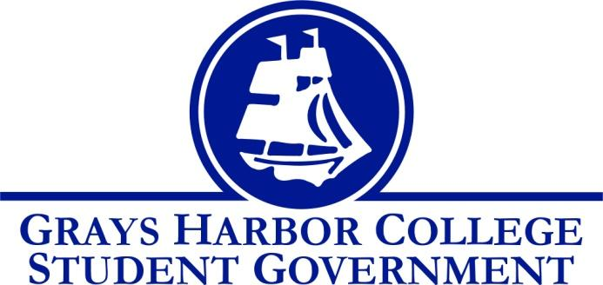
Council Meeting Minutes
February 1st, 2017 @ 1:00 P.M.

Call To Order
1:05 P.M.
Roll Call
Yulisa Morelia
Savannah Burbank
Sierra Cummings (excused)
Taylor Moreno
Chloe Converse
Approval of Agenda
Taylor Moreno motions
Chloe Converse seconds
Vote passes 3-0-0
Approval of Minutes
Taylor Moreno motions
Savannah Burbank seconds
Vote passes 3-0-0
New Business

Statements from the Gallery
Andrew Glass (Chief Executive of Technology Information) came in to update us on the tach fee account. He explained that the account as accrued quite a bit of debt and that he will be working on reducing it as much as he can. One of the ways he plans on reducing it is by taking some salary costs from the tech fee and instead taking them out of the colleges budget.
Executive Reports

President (Yulisa Morelia)
- Yulisa accounced that her and Jen Barber are starting a support group for immigrants and undocumented students.
- She also reminded everyone to finalize their pages on CANVAS so that we can move forward with that.
Vice-President (Savannah Burbank)
- No report
Executive Officer of Government Relations (Chloe Converse)
- No report
Executive Officer of Budget & Finance (Sierra Cummings)
- Absent (excused)
Executive Officer of Community Relations (Taylor Moreno)
- Taylor discussed doing a Krispy Kreme fundraiser for Relay for Life and asked input on when a good time would be as well as price suggestions.
- He also discussed the trivia night fundraiser and explained some changes that he will be making some changes for the next one.

Advisor Report (Aaron Tuttle)
Aaron brought up the “Oohlala” app and discussed whether or not we want to sign another contract to keep the app going.
He also asked everyone’s opinion on getting more digital signage so that we can place them in different places around campus.

Unfinished Business

Announcements
Executive Session
Adjournment
Taylor Moreno motions
Chloe Converse seconds
3-0-0
1:45 P.M.

