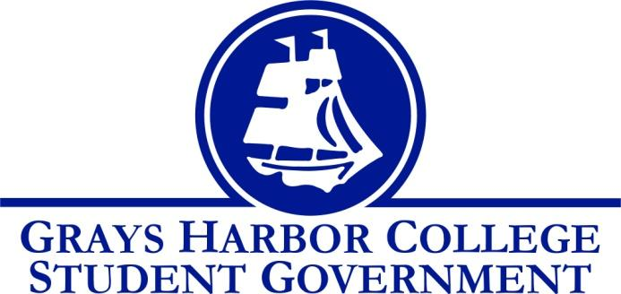
Council Meeting Minutes
February ^{15th} , 2017 @ 1:00 P.M.

Call To Order
1:02 P.M.
Roll Call
Yulisa Morelia (excused)
Savannah Burbank
Sierra Cummings
Taylor Moreno
Chloe Converse
Approval of Agenda
Sierra Cummings motions to amend and add changes
Chloe Converse seconds
3-0-0
Savannah Burbank motions to add “bylaws” to her update
Taylor Moreno motions
Chloe seconds
3-0-0
Approval of Minutes
Sierra Cummings motions
Taylor Moreno seconds
Vote passes 3-0-0
New Business
Chloe Converse motions to approve changes to the Bylaws, Financial Code, and Constitution regarding the tech fee and senate
Taylor Moreno seconds
3-0-0
Statements from the Gallery

Executive Reports

President (Yulisa Morelia)
- Absent (excused)
Vice-President (Savannah Burbank)
- Savannah updated everyone about the changes to the bylaws, constitution and financial code. She mentioned that she is going to post a MEMO about the changes made and a copy of each document so that all students have a chance to look at them before they are officially voted in.
Executive Officer of Government Relations (Chloe Converse)
- Chloe told everyone that she’s going to be keeping an eye on current legislative issues and bills.
Executive Officer of Budget & Finance (Sierra Cummings)
- Sierra has been making flyers to hand out for games. She asked input on whether posted or flyers were more effective.
- She is also waiting on the tech fee and budget packet to be digitalized.
- She talked about possible ideas for sophomore night for Men’s/Women’s Basketball.
Executive Officer of Community Relations (Taylor Moreno)
- Taylor has 49 people signed up for Krispy Kremes and is just working on getting all their money turned in.
- He also discussed prizes for trivia night and different ways to secure the cuss jars.
Advisor Report (Aaron Tuttle)
- Aaron asked for input on what we want to do with the app for future years.
- He reminded everyone that the staff meeting is March 2nd.
- He handed out application packets from last year with some changes and discussed possible changes that would improve student understanding of their position.
- Asked group to write up a short paragraph about how their positions by February 24th.
- He discussed results of HUB forums.

Unfinished Business

Announcements
Executive Session
Adjournment
Taylor Moreno motions
Sierra Cummings seconds
3-0-0
1:53

