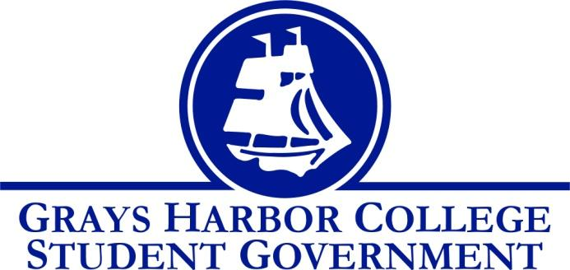
Council Meeting Minutes
March 1st, 2017 @ 1:00 P.M.

Call To Order
1:01 PM
Roll Call
Yulisa Morelia (excused)
Savannah Burbank
Chloe Converse
Sierra Cummings
Taylor Moreno
Approval of Agenda
Sierra Cummings motions to approve
Taylor Moreno seconds
3-0-0
Approval of Minutes
Sierra Cummings motions to approve
Taylor Moreno seconds
3-0-0
New Business

Statements from the Gallery

Executive Reports

President (Yulisa Morelia)
- Absent (excused)
Vice-President (Savannah Burbank)
- Savannah reminds everyone that we are waiting the 15 days for the constitution changes to elapse.
Executive Officer of Government Relations (Chloe Converse)
- Chloe informs the group of the status of senate bill 5820, and tells us how it would affect GHC students.
- She also met with Dr. Minkler and updated the group about their discussion regarding the HUB funding
Executive Officer of Budget & Finance (Sierra Cummings)
- Sierra let everyone know that a digital budget packet has been created.
- She also asked for recommendations for faculty for the Budget Committee.
- She also let us know that clubs now have to go to budget school so that they can train treasurers for requests.
Executive Officer of Community Relations (Taylor Moreno)
- Taylor presented a list of fundraisers and prospective dates and asked for group input.
Advisor Report (Aaron Tuttle)
- Aaron asked for opinions on Diversity Center logo.
- He told us the dates for Voice Academy are May 5th and 6th.
- He told us Student Life applications and budget packets will go out next week.
- Reminded everyone of the all staff meeting on Thursday, March 2nd.
- He let us know that we might have 2 budget packets to review next week.
- He asks us about the possibility of a Farmers Market on campus.

Unfinished Business

Announcements
Executive Session
Adjournment
Chloe Converse motions to adjourn
Taylor Moreno seconds
3-0-0

