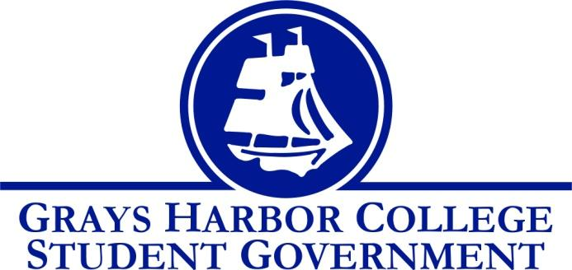
Council Meeting Minutes
April 13th, 2017 @ 12:00 P.M.

Call To Order
12:03 PM
Roll Call
Yulisa Morelia
Savannah Burbank
Chloe Converse
Taylor Moreno
Approval of Agenda
Chloe Converse motions to approve
Taylor Moreno seconds
3-0-0
Approval of Minutes
Savannah Burbank motions to approve
Chloe Converse seconds
3-0-0
New Business

Statements from the Gallery

Executive Reports

President (Yulisa Morelia)
- Yulisa updated us that she is working on the power point to present at the board of trustees meeting.
Vice-President (Savannah Burbank)
- No report
Executive Officer of Government Relations (Chloe Converse)
- No report
Executive Officer of Budget & Finance
- Position currently not filled
Executive Officer of Community Relations (Taylor Moreno)
- Taylor updated us all on the Relay for Life fundraisers. He said that he is advertising for luminaries and is talking with staff about prize baskets.
Advisor Report (Aaron Tuttle)
- Aaron updated everyone about the oohlala app and said that integrating it with canvas is not an option.
- Gave us the updated dates for the club banquet and transition day.
- Announced that he will need some of us to be on the hiring committee for next year’s Student Life team.
- Updated everyone on the most recent budget dates and requests.
Unfinished Business
Keith Penners funding request won’t be approved until he orders recycling bins.
Announcements
Executive Session
Adjournment
Chloe Converse motions
Taylor Moreno seconds
12:34

