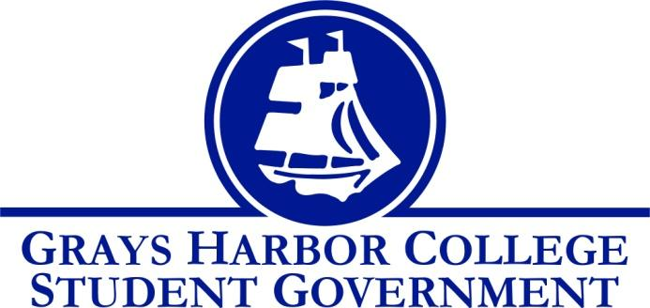
Council Meeting Minutes
October 2, 2017 @ 1:00 P.M.

Call to Order
1:01 PM
Roll Call
Liz Allton
Sage Baker
Taylor Miller
Christopher Burk
Andy Gonzales
Aaron Tuttle
Approval of Agenda
Taylor motions to approve agenda and minutes
Sage seconds
4-0-0
Approval of Minutes

New Business
- PTK
What did you learn?
-Golden Opportunity Scholarships for PTK members
-Communication skills and Interpersonal Critical Thinking
-Ideas for college Project (Soft skills Workshop open to all GHC student)
-Recruitment and how to get involved
-Honors in Action Project
4 steps to HIA
- Investigating & Analyzing
- Strategizing
- Act & Serve
- Assessing what your impact was

-Team Building Activities
-Getting to know e/o and working together as a group to promote PTK and GHC students
-Fundraising ideas
Statements from the Gallery
.
Executive Reports
President (Liz Allton)
- Survey
-October 10, 2017 @9 AM
-Chris is available and Liz can present to E-Team
-Classes are not to be skipped in order to make it to presentation
- Strategic Planning Committee
-Liz reached out to Kristy and Darren including more students on subcommittees
-Chris was on tech committees in the past and has experience
-Liz asks student governments interests concerning committees
-Aaron explains that the whole idea behind was to add student representation
-We would be thrown into these committees, because they have been going on for a year now. No worries because committees would set you up to speed.
-Some committees are but not limited to Master Plan Committee, Strategic Enrollment Committee, Tech Committees, and etc.
-Only students who are academic transfers are able to join committees
- Meeting Your Student Government Debrief
-Felt rushed
-Taylor felt excluded location wise (different locations next time around)
-Instead of one-hour change to two
-Positive feedback, heard complaints about vending machine prices. Unfortunately, the college has no control over prices because tis and outside vendor.
-Student Government Will do a Meet and Greet e/ quarter
- Out of the Darkness Walk
-October 8, 2017 @9 AM-1 PM
-Volunteers?
-Chris is available
-Andy will check schedule

- Campus Safety
-Lance does safety videos during orientation (Run*Hide*Fight)
-Door Magnets
-Darby demonstrated the shut and lock
-Murrel also gave a little presentation on the locks
-The magnets on the door locks keep the door from locking, you only remove magnet in case of threat
-Jerad clarifies that the doors are always locked- magnets prevents the door from locking
-Liz mentions, “Is this the best way to keep student’s safe?
-Jerad and Dr. Minkler have thought about completely retrofitting the campus. The cost estimated currently is $700,000
-Jerad says that if this is something you really want, student government will need to make this one of their number initiatives. We would have to ask questions: such as the age of the building.
Vice-President (Sage Baker)
- Budget Committee
-We need to decide who were going to assign. Possibilities of senators being assigned is likely. As of right now we are thinking of asking Mitch from GHAB to join as well.
-If all senate applications aren’t turned in on time the bylaws state we would maintain quorum without senators.
Executive Officer of Government Relations (Andy Gonzales)
- Voting Registration Drive
-Andy will be creating a schedule for tabling
-A frames will be displayed around the campus
-Hand bills are going to be printed
-Andy got into contact with Chris Thomas and discussed when he could visit the campus. Aaron suggests that Andy asks Chris to bring forms. Also Andy will need to ask Chris what he needs from a set up stand point.
Executive Officer of Budget & Finance (Taylor Miller)
- Budget Report
-Made rough draft for budget timeline
-Dates are tentative
-Taylor mentioned a concern with the bylaws. He wants to extend the amount of years one can serve from 2 years to 4. Taylor says that now there are 4 year programs it would only be fair.
Executive Officer of Community Relations (Christopher Burk)
- Blood Drive
-39 people are signed up as of now, if they will attend only time will tell. So far on a very track.
-Main focus is too advertise
-There are blank times available for tabling. We will ask members of GHAB specifically Mitch and Jerad.

Advisor Report (Aaron Tuttle)
- Legislative Academy
November 17th & 18th
Olympia (Red Lion Hotel)
- Latinx Youth Conference
October 6th
If you are available to volunteer don’t forget to sign up
- Club Recruitment
-next week
-Involvement fair 10/10/17
-Club mixer 10/12/17: Will include Board games, video games, refreshments
- Luis Ortega
-Thursday 12:00- 1:00
- student government is required to see one speaker per quarter
- SG Canvas Page
-Student government now has its own canvas page; we are all instructors. This is a way for student government to communicate what they are doing.
Tech Needs
-There is a need for funding for a new setup (A/V cart). The projector is 15 years old, and a 5-year-old laptop. A quote for these items brand-new would be $5500. Another $600-1000 for the cart itself.

Unfinished Business
- Dr. Lardner
We need to follow up with her by creating a list of demands for the division chairs, faculty union and/or e-team
- Keith Penner
Liz Allton emailed him this morning asking him to email her what recycling bins he had previously mentioned that were cheaper than the original ones previous Student Government wanted him to buy

Announcements
Executive Session
Adjournment
Sage motions to adjourn the meeting at 2:09 PM
Taylor seconds
4-0-0`

