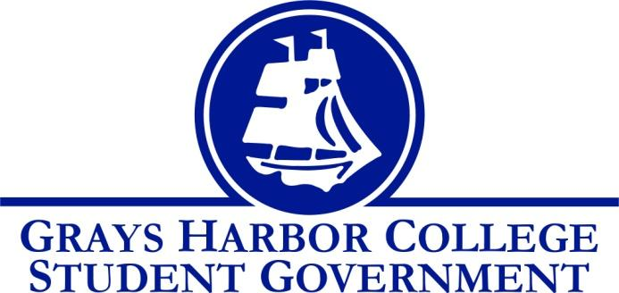
Council Meeting Minutes
October 9, 2017 @ 1:00 P.M.

Call To Order
1:00 PM

Roll Call
Liz Allton – Not Present (excused)
Sage Baker
Taylor Miller
Christopher Burk
Andy Gonzales
Aaron Tuttle
Approval of Agenda
Taylor motion to approve agenda
Chris seconds
4-0-0
Approval of Minutes
Taylor motions to approve minutes
Chris seconds
4-0-0

New Business

Statements from the Gallery
.
Executive Reports
President ( Liz Alton)

Survey
Oct.10 Liz and Aaron will present to E-Team
Oct.16 is projectile release date

Fall Festival
Held on Oct.30
Need ideas for booths submitted by Oct.20
Booth Ideas
        - Face painting
        - Fishing for prizes
        - Pie-in-the-Face
        - Cookie decorating

Osaka College of Nursing Students
Oct.18
Welcoming students to campus
Dr. Winkle has special ties with Osaka

Vice-President ( Sage Baker)

- Senate Applications
3 applicants

Executive Officer of Government Relations ( Andy Gonzales)

- Voter Registration Drive
Set up A-Frames
15 registered
Reschedule with the County Auditor, Chris Thomas, to come table on campus.
Create doodle for this week's tabling. If possible, sign up for available time.

Executive Officer of Budget & Finance (Taylor Miller)

- Budget Report
Same as last weeks. No new changes.
Sent email to Andrew Glass to set up a meeting about the tech fee and S&A budget.
- Budget Committee
Need a faculty rep and club rep

Executive Officer of Community Relations (Christopher Burk)

    - Blood Drive
Complete success. Successfully donated a total of 14 pints of blood.
Had 14 first timed donors of the total 38 donors.
Received recognition from sponsored spotlight
    - Out of the Darkness Walk
Complete success, Barbra didn’t not need any more volunteers.
Aaron recommends to attend early to reserve a spot to volunteer

Advisor Report (Aaron Tuttle)
  - WACTCSA Agenda
    - Legislative Academy
Nov. 17 and 18
Olympia. Overnight stay at the Red Lion Hotel
Andy, Liz and Taylor will be attending

    - Campus Committees
Each member was assigned a tenure and committee
    - Student Gov Canvas Page
Go online into Canvas. We are all instructors. Update and submit any new or upcoming information regarding your agenda and role.

    - BBQ for Japanese Nursing Students
Oct. 18
Student life will be providing lunch service
From 10:45am to 1:00pm
If your available to help came and volunteer

Unfinished Business

Dr. Lardner
    - We need to follow up with her by a creating a list of demands for the division chairs, faculty and/or e-team
    - Example: seeing faculty reviews
Keith Penner
    - Please see handout for more info on the bins we are ordering

Announcements
Executive Session
Adjournment
Taylor motion to adjourn meeting at 1:32pm
Chris seconds
4-0-0

