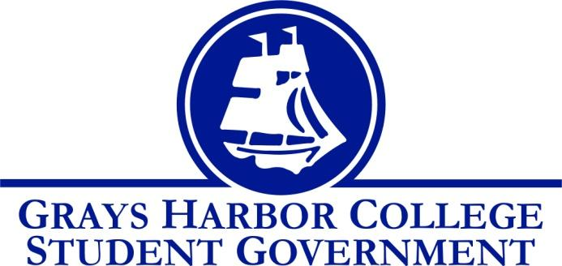
Council Meeting Minutes
October 30, 2017 @ 1:00 P.M.

Call To Order
1:02 PM
Roll Call
Liz Allton
Sage Baker
Taylor Miller
Christopher Burk
Andy Gonzales
Aaron Tuttle
Approval of Agenda
Sage motions to approves this week’s agenda along with last week’s minutes
Taylor seconds
6-0-0
Approval of Minutes

New Business

Statements from the Gallery

Executive Reports
President (Liz Allton)
- Fall Festival
- Survey
    - 235 responses
- Canvas page
    - Published on the first of the month
- Meet w/ the President
    - Tomorrow @ 3 PM
Vice-President (Sage Baker)
- No report
Executive Officer of Government Relations (Christopher Burk)
- no report
Executive Officer of Budget & Finance (Taylor Miller)
- Budget Report
  - Contingency account is still at $26,050

Executive Officer of Community Relations (Andy Gonzales)

- Affordable Cost for Class Materials
    - Promote Survey
    - Deadline Oct. 31
- 2nd WACTCSA Southwest Region meeting
    - Terry Zhou, WACTCSA Southwest Representative
    - Pierce College Fort Steilacoom

Advisor Report (Aaron Tuttle)
- Legislative Academy is on November 17-18 and will be leaving by 11:00am to arrive by 12:00pm. I need to hear a final number of who is going and not.
- All Staff Meeting: The all staff meeting is on Friday at 8:00am please be here on time.
- Budget Update: In looking at budgets at the end of last year there was over $77,000 that should have been transferred to the Fund Balance account but has not. I have informed Liz and Taylor about it. I have emailed Nick and included Jerad. Jerad informed me that Nick is looking into it.
- Wednesday, November 1st I will be out in the morning until 12pm or 1pm reviewing VPSS applications.
Unfinished Business
- Dr. Lardner
  - We need to follow up with her by creating a list of demands for the division chairs, faculty union and/or e-team
- Keith Penner
  - Waiting for update

Announcements
Executive Session
Adjournment

