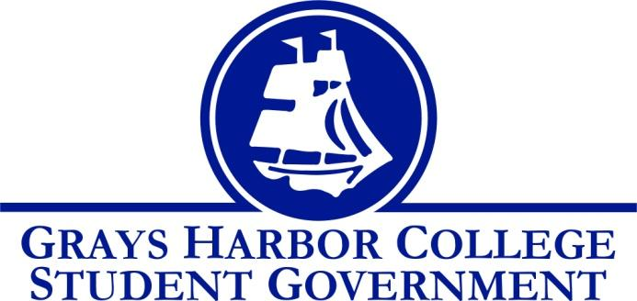
Council Meeting Minutes
January 26th, 2018 @ 9:00 A.M.

Call To Order: 9:04

Roll Call
Liz Allton
Taylor Miller
Christopher Burk
Andy Gonzales
Guadalupe Leon
Diana Silva-Diaz
Montanna Schreder - absent
William Hardy
Aaron Tuttle

Approval of Agenda Taylor motions to approve the agenda, Will seconds 6-0-0
Approval of Minutes Will motions to approve the minutes, Taylor seconds 6-0-0

Statements from the Gallery 5 minutes
- Please see handout
Dr. Lardner informed the group that Jerad Sorber and Belen Chavez (DSS Coordinator) also received an email with this letter too. Liz will invite Keith Penner to talk about ways to make the campus more accessible.

New Business 10 minutes
- Funding Requests
  - E-Sports Gaming Club
  - Total Requesting $ 5,400
Tony Prindel talked about the different items in the request. Graphics cards, mice, mouse pads, head phones.
Taylor motioned to approve up to $5,400
Will seconds
6-0-0

Unfinished Business 30 minutes
- Funding Request
  - Trio
Christopher motioned to approve up to $506 for meals on the TRIO trip.
Will seconds
4-0-1

- Dr. Emily Lardner (Vice President of Instruction)
  - Tutoring/Learning Support Services
  - Faculty Hiring/Code of Conduct
  - Advising – Assessment for students to take

Will gave us an update on the Learning Support Services committee. They have been discussing what Learning Support Services should look like, do we need to have them all in one place or is it better to have them across campus. The committee has been reviewing the survey results as well. Dr. Lardner feels that Will is an important part of the committee, is listened to, and taken seriously. The question that Dr. Lardner raised was why don’t students go get help? While the survey was a good base, the committee needs more in depth research.

Liz will share survey results at the next BOT meeting.

In February there will be a campus wide employee climate survey. This will help identify areas of concern and push forward the conversation of civility. Liz asked that students be a part of that conversation and code of conduct process. Jerad and Aaron are working on flow charts to outline the grievance process to make it easier for students to understand.

The faculty were shaken up after SG requested students have access to evaluations. Liz will send out an email to gage interest in forming a committee to create an advising assessment. Taylor volunteered to be a part of that committee. Aaron and Dr. Lardner were recently in a meeting evaluating New Student Orientation. Could this assessment be incorporated somehow?

Dr. Lardner knows what courses faculty want to teach but she would also like to know what type of Humanities courses students would like to take. SG will look into a few other colleges, what they offer, and give Dr. Lardner a list of ideas.

- Plotter Printer Charges
  - William’s recommendation
  - How much are we going to charge?
Decision will be made next meeting.

Executive Reports

Executive Officer of Government Relations (Andy Gonzales) 5 minutes
- No report

President (Liz Allton) 15 minutes
- Athletic Over Expenditure: Unfortunately, the coffee cart revenue projections won’t be enough to support a food bank. Since this was part of our over expenditure resolution, we have to figure out how to proceed. We have three main options.
  - Ask for the full $75,000 back in full
  - Set up a payment plan of $10,000 (or $7,500) a year until it has been paid back
  - Eat the entire cost of the over expenditure
The group discussed a variety of payment plans and decided to ask for the amount over an eight year period.
- Ooh la la
  - Choker Nation app
    - Sending out a survey via email, the app itself, and tabling
    - Taylor and I will report back to you all with our findings
Liz will send Andrew Glass the survey link to put on the GHC portal
- Strategic Planning Committee Update:
  - Last meeting the group went over the reports from the different Core Themes and Topic Specific groups to find similarities in goals and figure out our direction for the rest of the year
- Students of Color Conference
  - April 12th- 14th in Yakima, WA
  - Opportunity to expand your diversity education
  - The deadline for submitting completed application is Friday, February 2nd by 4:00pm.
- Please make sure I get your weekly report on Wednesdays to ensure they make it onto the agenda

Vice-President
- No report

Executive Officer of Budget & Finance (Taylor Miller) 5 minutes
- Budget Report
  - Contingency account
The contingency account is at 25,402.95
- Visiting the Raymond campus
  - Dates: February 12th-15th When are people available?
Taylor will re-send out a Doodle with prospective days and times to visit the Raymond campus.
- This past week Liz and I worked on a survey for the ChokerNation app

Executive Officer of Community Relations (Christopher Burk)
- No report

Senators

Guadalupe Leon
- No report
Diana Silva Diaz
- No report
Montana Schreder
- No report
William Hardy
- No report

Advisor Report (Aaron Tuttle) 15 minutes
- Food bank
  - I was invited to a preliminary conversation about a food pantry/bank. This is to talk about program and grant development. This group will consist of Lisa Smith and JEB Thornton. As Lisa mentioned they put in a proposal for an Americorp. We will be including Liz in this meeting the next go around.
- Biographies
  - I only received some of your biographies for my report for Jennifer Alt when she starts as the new Vice President of Student Services
Aaron still needs Chris, Montanna, and Diana’s biographies.
- Oohlala:
  - Everyone needs to help promote the app and the survey that Liz and Taylor created do gauge student interest in continuing to use the app.
- GSA has updated their bylaws and Student Government now can agree to adopt or make suggestions to the document.
Aaron will have a draft of another club handbook update that outlines how to ask club advisors to leave.

Announcements
Executive Session
Adjournment

Taylor motions to adjourn at 10:29
William seconds
4-1-0

