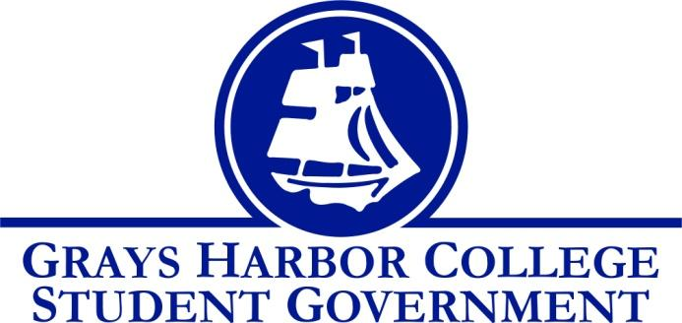
Council Meeting Minutes
February 2nd, 2018 @ 9:00 A.M.

Call To Order: 9:02

Roll Call
Liz Allton
William Hardy
Taylor Miller - absent
Christopher Burk
Andy Gonzales
Guadalupe Leon
Diana Silva-Diaz - absent
Montanna Schreder
Aaron Tuttle

Approval of Agenda Will motions to approve the agenda, Lupe seconds 5-0-0
Approval of Minutes Christopher motions to approve the minutes, Will seconds 5-0-0

Statements from the Gallery

New Business 10 minutes
- Funding Requests
  - Phi Theta Kappa
    - Total requesting: $11,793.35

Every two years at the PTK Catalyst Conference a new topic is released. This topic corresponds to the Honors in Action project a chapter must complete to achieve or maintain five-star status. Two GHC students will already be attending the conference as regional officers and paid for by the region. This year our chapter hosted the Fall conference, as a fundraiser. Most projects are happening and are due in the fall, leaving little time for fundraising. The chapter will also be hosting the spring regional conference. Advisor Deanna talked about the educational sessions they have at these conferences, that they are very informative and she feels like they help her become a better advisor. PTK has in previous years went out to serve the homeless population, but now they focus on more internal projects. Questions about the amount of the request were raised, as well as the status of the members hoping to go. Are the students all graduating? Two are coming back, potentially three.

Will motioned to approve up to $6,500 for two students and one advisor to attend the PKT Catalyst Conference
Chris seconded
5-0-0

  - Andrew Glass (Chief Executive of Information Technology)
    - Total requesting: $2,898
Andrew Glass requested funds to bring in a part time developer to work on a student portal and book exchange.

Will motioned to approve Andrew’s request of $2,898
Lupe seconded
5-0-0

- Keith Penner (Chief Executive of Campus Operations)
  - Accessibility concerns and questions
Currently the campus meets ADA standards and international building codes. This summer the 200 & 300 buildings will be torn down and the parking lot will be renovated to be more accommodating (more ADA parking.) There will also be more sight lighting added and better drainage in the lot. Eventually the HUB will be torn down and more parking will be added. Keith spoke of a shuttle in Fall 18 to alleviate some of the parking issues that will be created over summer.
Liz will send Keith the Rec & Wellness survey. We have some funds to use for capital projects. The project ideas included more student (non athlete) space and raising the roof. Keith will report back next meeting.

Unfinished Business 30 minutes
- Dr. Emily Lardner (Vice President of Instruction)
  - List of Humanities courses for Dr. Lardner
- GSA has updated their bylaws and Student Government now can agree to adopt or make suggestions to the document
Liz will send GSA President Rainbow Rose a memo to add quorum for meetings, not just elections.

Executive Reports

President (Liz Allton) 15 minutes
- Athletic Over Expenditure
  - Memorandum of Understanding
    - Outlines payment plan and where the money will go.
- Ooh la la (Choker Nation app)
  - Taylor and I will report back to you all with our findings

Will motioned for Aaron not to submit a funding request to renew the ChokerNation app
Andy seconded
5-0-0

- I will email Dr. Lardner to ask her for a list of questions that we can ask Raymond students on our visit

Vice-President
- I am recommending that we charge $1.25 per square foot of paper used in the plotter printer.

Aaron would like the math for the standard poster sizes.

Executive Officer of Budget & Finance (Taylor Miller)
- No report

Executive Officer of Community Relations (Christopher Burk)
- I have changed the schedule a bit and removed game night.
- Penny Wars is my main focus.
  - I need 4 people, one from each group: faculty, staff, student, exempt.
  - Positive and negative point system:
    - Pennies are positive and keep people from getting a pie in the face.
    - Anything other than pennies are negative points and bring the people closer to a pie in the face.
    - Whoever has the least amount of points (negative) gets a pie in the face.
- I would like to talk about getting money for 8 big collecting jars at the meeting.
- I am inviting any and all of Student Life workers to the Grays Harbor College Student Life Relay team.
- I plan to table to talk about Relay sometime the next week and a few times during Penny Wars from February 9-26th. I will set up a doodle and ask you all to help if you can.
- Relay Schedule
  - “Fire Relay” Chili Cook Off: Thur. January 18.
  - Penny Wars: Feb. 9-26
  - Donut Stress Krispy Kreme: Feb. 28-March 7
  - Basket Silent Auction: May 7-11
  - Car Wash: Thur. May 24
  - Cornhole Tournament: Thur. May 31
  - Trunk Sale: I am going to email Keith Penner.
Keith saw no immediate reason why a trunk sale wouldn’t be possible. Keith will double check that we won’t be violating any rules.

Executive Officer of Government Relations (Andy Gonzales) 5 minutes
- WACTCSA General Assembly Meeting
  - Legislative Bill Tracker Handout
  - Bills gaining momentum
    - 2SHB 1293
      - concerning witnessing a student's college bound pledge when efforts to obtain a parent's or guardian's signature
    - 2SHB 1298
      - prohibiting employers from asking about arrests or convictions before an applicant is determined otherwise qualified for a position
    - SB 5070 (Higher Education for Undocumented Students)
      - an act relating to aligning eligibility for the college bound scholarship program with the state need grant program
- Textbook and Open Educational Resource Affordability and Accessibility Survey
  - Over 10,000 responses in the study period from Sept. 27- Dec.22 2017
  - The creator of the survey, Dr. Boyoung Chae talks of the possibly of a national survey
  - Key Findings
    - The threshold amount of what students accept as a low-cost textbook is $50 or less
    - 80% of students claimed they withdrew from course(s) due to high cost materials
    - 44% of students have sometime/often taken courses without the required materials
    - 71% of students stated their financial aid money hasn’t arrived on time to purchases course materials
    - In the section of students giving their open responses, most have state they would like to have...
      - Promotion of open/free materials and policies for affordability
      - Favorable rates for buybacks, rent. and materials that can’t be resold
      - Avoid costly homework course
      - Indicate required vs. optional materials

Senators

Guadalupe Leon
- No report
Diana Silva Diaz
- No report
Montana Schreder
- No report

Advisor Report (Aaron Tuttle) 15 minutes
- Biographies
  - Please submit your biography if you haven’t already

Announcements
Executive Session
Adjournment

Andy motions to adjourn at 10:18
Will seconds
4-1-0

