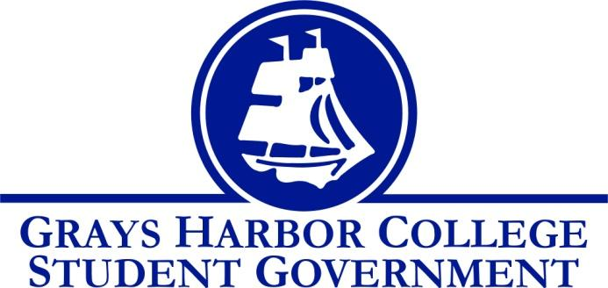
Council Meeting Minutes
April 18th , 2018 @ 2:00 P.M.

Call To Order: 2:01pm

Roll Call
Liz Allton
Taylor Miller
Christopher Burk
Andy Gonzales
Guadalupe Leon
Diana Silva-Diaz
Cameron Johns
Aaron Tuttle

Absent: William Hardy

Approval of Agenda: Taylor Motions to pass agenda. Motion is second and passes 6-0-0

Statements from the Gallery
- None

Unfinished Business
- Stafford Creek (Dr. Minkler)
  - Andy will contact Ricky Aguilar to build positive relations with Walla Walla Student Government
- Funding Requests
  - Grays Harbor College Nursing
    - $ 996.00
  - Taylor motions to approve $100 for the Nursing pinning ceremony. Cameron seconds and passes 6-0-0

New Business
- No new business

Executive Reports

President (Liz Allton)
- Working on updating posters
  - Helen Thayer Wednesday May 16th in 4134
  - Applications for next year
- Please volunteer an hour or so tomorrow for the campus day of service
- Food Pantry is now open on Tuesdays!

Vice-President (William Hardy)
- Bylaws Committee will meet weekly on Mondays beginning April 30th.
- Several people have taken senator applications and are working on collecting signatures.

Executive Officer of Budget & Finance (Taylor Miller)
- Budget Report
  - Contingency account is at $8,396.94
- Raymond trip: Doodle with time and date for student government trip to Raymond. Please pick the time that you know that you can attend.

Executive Officer of Community Relations (Christopher Burk)
- I am starting on Blood Drive stuff and will set up tabling times for it soon
  - Needs Volunteers for silent auction

Executive Officer of Government Relations (Andy Gonzales)
- Attend Voice Academy
  - May 4-5
  - Description: Recap and reflection on the just completed Legislative Session and provides students an opportunity for schools to propose issues for next year's agenda
- Table for Voter Registration

Senators

Guadalupe Leon
- No report
Diana Silva Diaz
- No report
Cameron Johns
- No report

Advisor Report (Aaron Tuttle)
- Community Relations duties:
  - I would like to propose that the community relations officer no longer do Relay for Life, but work with the AmeriCorp in the Food Pantry. This would better align with serving students and could be responsible for coordinating day of service and other service activities.
    - Chris agrees to Aaron’s recommendation to focus more in the Food Pantry
- Food Pantry Update:
  - We were open for the first time on Tuesday. We will be making adjustments to what we do moving forward but this whole process will be a learning period. One thing I am working to secure is another freezer, as we do not currently have enough space. Keith Penner is working to get me a quote. Additionally, it looks like we will be receiving an additional $10,000 dollars next year for food from the Just in Time funds. We can thank Margo Hood and Jennifer for this. I had a conference call this morning about the hiring of the AmeriCorp for the food pantry. I would like to have two students sit on the hiring committee in late June or July.
    - Aaron asks to help advertise the Food Pantry to increase turnout
- Hiring for Fall:
  - Don’t forget that we are hiring for fall and that applications are due Friday. Please continue to recruit students both currently enrolled and students who may be enrolling in the fall.
    - Students applications have been extended to May 2nd
- Voice Academy:
  - We have Voice Academy in two weeks. I have Andy, Liz, Taylor, Will, and Cameron going. We will leave at 8:00am on Friday. Andy at the next meeting could you give an update next week about where WACTCSA ended in the legislative session.
Announcements
Executive Session
Adjournment Taylor motions to adjourn meeting at 2:45pm. Chris seconds and passes 6-0-0

