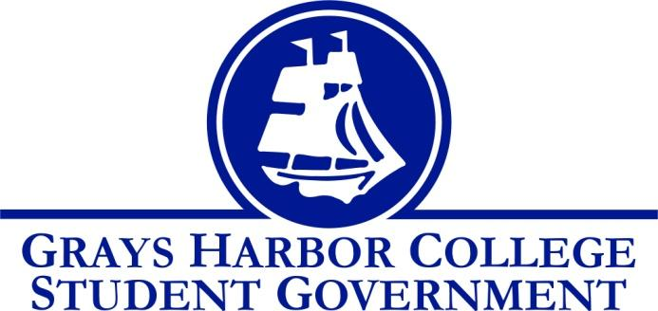
Council Meeting Minutes
October 4th, 2018 @ 1:00 P.M.

Call To Order 1:00pm

Roll Call
Mitchell Margaris
Kaden Coty
Taylor Miller
Roina Ma’afala (Absent)
Aaron Tuttle
Lindsey Coulson
Andrew Glass (Absent)
Dr. Jennifer Alt

Approval of Agenda
Approval of Minutes
Taylor motions to approve the minutes and the agenda with the amendment to new business. (Auto Club), Kaden Seconds.
Vote passes 2-0-0.

Statements from the Gallery (None)

Unfinished Business (None)

New Business
- GSA Contingency Request – GSA requested funds to attend a “Queer I Am” event.
  - Taylor motioned to approve $1,806.81 in funding, Kaden seconds. Vote passes 2-0-0.
  - GSA plans on going to Pride, putting on the annual Drag Race, potentially volunteer at Fall Festival, and fundraise for Rocky Horror.
- Automotive Club – Students came together to discuss creating this club.
  - Kaden motions to approve the automotive club, Taylor Seconds. Vote Passes 2-0-0.
- Fall festival – Student Government Discussed multiple options for Fall Festival, but has decided on a Haunted Hay Ride.
Executive Reports

President (Mitchell Margaris)
- I will be sending an email out to Stacy Barnum either today or tomorrow to get an update on the batting barn. I am also going to send an email out to the city transit system to see about possible shuttle benefits coming from them.
- Kaden, Lindsey, and I will be collecting applications and setting up interviews next week after Wednesday deadline.
- Kaden and I will also be getting together to place candidates in to committees. We need to push to get senators as soon as we can.
- Aaron has given me some materials and information about connections with Stafford Creek, so expect an email coming out with ideas and such looking for your feedback.
- What do we want to do at Fall Festival?
- The Food Drive starts next week (the 12th) and we are going to have a team for our office. We also need to start talking smack to other departments (Student Services, Instruction, Financial Aid, etc.) in efforts to try and get them to form teams and compete. This will be a really fun event and have a lot of benefits from it!

Vice-President (Kaden Coty)
- I now have Taylor, Ina, Dakota, and Andy’s committee applications.
- I helped out at the Blood Drive on Monday, and we got a few Walk-Ins!
- The Government Relations Application Posters are starting to be taken down, and I finished updating the new poster with the extended deadline.
- I may need help taking down the flyers across campus, but we do not need to put new ones up, the posters should suffice.
- The applications have been updated and printed out with the position change from “Executive Officer of Budget and Finance” to “Executive Officer of Government Relations”, sorry Taylor.
- I’ve tabled for the Government Relations and Senator positions a little bit with other items like the food pantry, but I think we should really try to push the applications this week and next.
- Side Note: My ASVP email/ outlook account seems to be having some problems, like delivering emails, but I will try to work that out.

Executive Officer of Budget & Finance (Taylor Miller)
- The contingency account is at $29,160.00. (After the requests today, the account is $27,153.19).
- Next week is last week that we can mail in/ online do the voter registration we have until 8th and after that until 29th we drop off at country office.

Executive Officer of Community Relations (Roina Ma’afala)
Food Pantry Week 3 (10/2)
- Served 107 students and community members
- New shipment of food will arrive next week Monday
- Higher volume of people because there is a change of variety. New schedule is going out for Student Life volunteers.
- Volunteer sign-ups and orientation for new volunteers is in progress.

Blood Drive 2018 (10/1 and 10/2)
- Day 1- About 8 appointments (served all 8) and 16 walk-ins (served all 16)
- Day 2- About 12 appointments (served 7) and 12 walk-ins (served 7) à 11 units of blood
- In the future, work on better organization of scheduling individuals in advance for the sign-in table.

Executive Officer of Government Relations (Vacant)

Senators (Vacant)

Advisor Report (Aaron Tuttle)

- WACTCSA Update: There will be a post-conference call on October 9th to check-in with campuses on their progress to engage students in civic initiatives within the first two weeks of the quarter, share details of the WACTCSA Regional Representative application, host a Q&A session and talk more about mobilizing WACTCSA and legislative engagement for the coming legislative session. Who can attend this call?
- Legislative Academy: Is coming up on November 16-17, 2018 at the RL Hotel in Olympia, WA with the academy beginning at 12 pm with lunch and the formal program beginning promptly at 1p. Who is willing and able to attend.
- Grays Harbor College Scorecard and Accreditation I have included an email about the college’s Year-Seven Report for Accreditation. Please feel free to review the document. Additionally, I have brought the college scorecard.
- New Hires in Student Services: There are two new individuals who will be working in Student Services they are the Associate Director of TRiO, Tony Garcia, and the new Director of Workforce Funding and Support Programs, Pete Keller.

Vice President of Student Services (Dr. Jennifer Alt)
- Parking is now all moved and reserved.
- I am gone next Monday – Thursday & the week after Wednesday – Friday.
- The emergency student funds have been moved to the institution, and have proved to have an excellent and valuable return for our college.

Announcements (None)
Executive Session (None)
Adjournment Mitch motions to adjourn the meeting at 2:20pm, Taylor Seconds. Vote passes 2-0-0.

