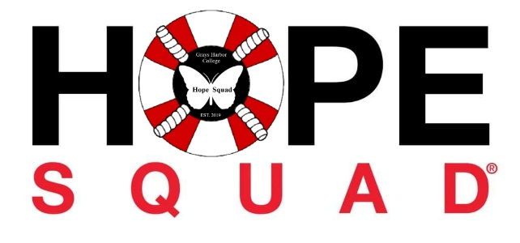

Grays Harbor College Hope Squad Meeting Minutes
May 14, 2025
- Call to order

Laura called the meeting to order at 4:40 pm

- Roll call
Officers
President: Absent
Vice President: Laura, Present
Treasure/Rep: Scye, Present
Secretary: Joy, Present
Public Relations: Nancy, Present

Members
Karen
Derek
Daniel
Adam

Statements of the gallery:
Discussion started to do tabling once a month, having a car wash on Father's
Day, and having a bonfire with all members. The members are also planning a small gathering for Cari’s birthday. Scye will provide ice cream, Laura will provide a special cake, and Joy will provide drinks and utensils.

- Approval for Agenda :

Karen motions to approve the agenda
Joy seconds the motion. Vote passes

Approval of Minutes:
Minutes could not be found
Karen motions to approve the minutes if found at the next meeting
Joy seconds the motion. Vote passes
Officers Reports:
President-No report
Vice President- Tabling went well. We had 3 full sheets of new members.
Treasurer- No Report
Secretary- Proud of how the group came together, and how we are supporting each other. Discussion of possible Hope Squad Camping trip (August 22-24).
Public Relations- No Report
Advisor- Nominations for new officers will be open for two weeks. Remember to take care of yourself. I will start working on the camping trip.
Unfinished Business

No unfinished business
New Business
Swag and Shirts
Scyeland motions to approve 300.00 for swag and 300.00 for t-shirts to be pulled from SL funds first. The remaining will be pulled from fundraising.
Derek seconds the motion. The vote passes.
Executive Session- No Session
Adjournment 5:24 pm

